New Supplier Application- Non-Merchandise
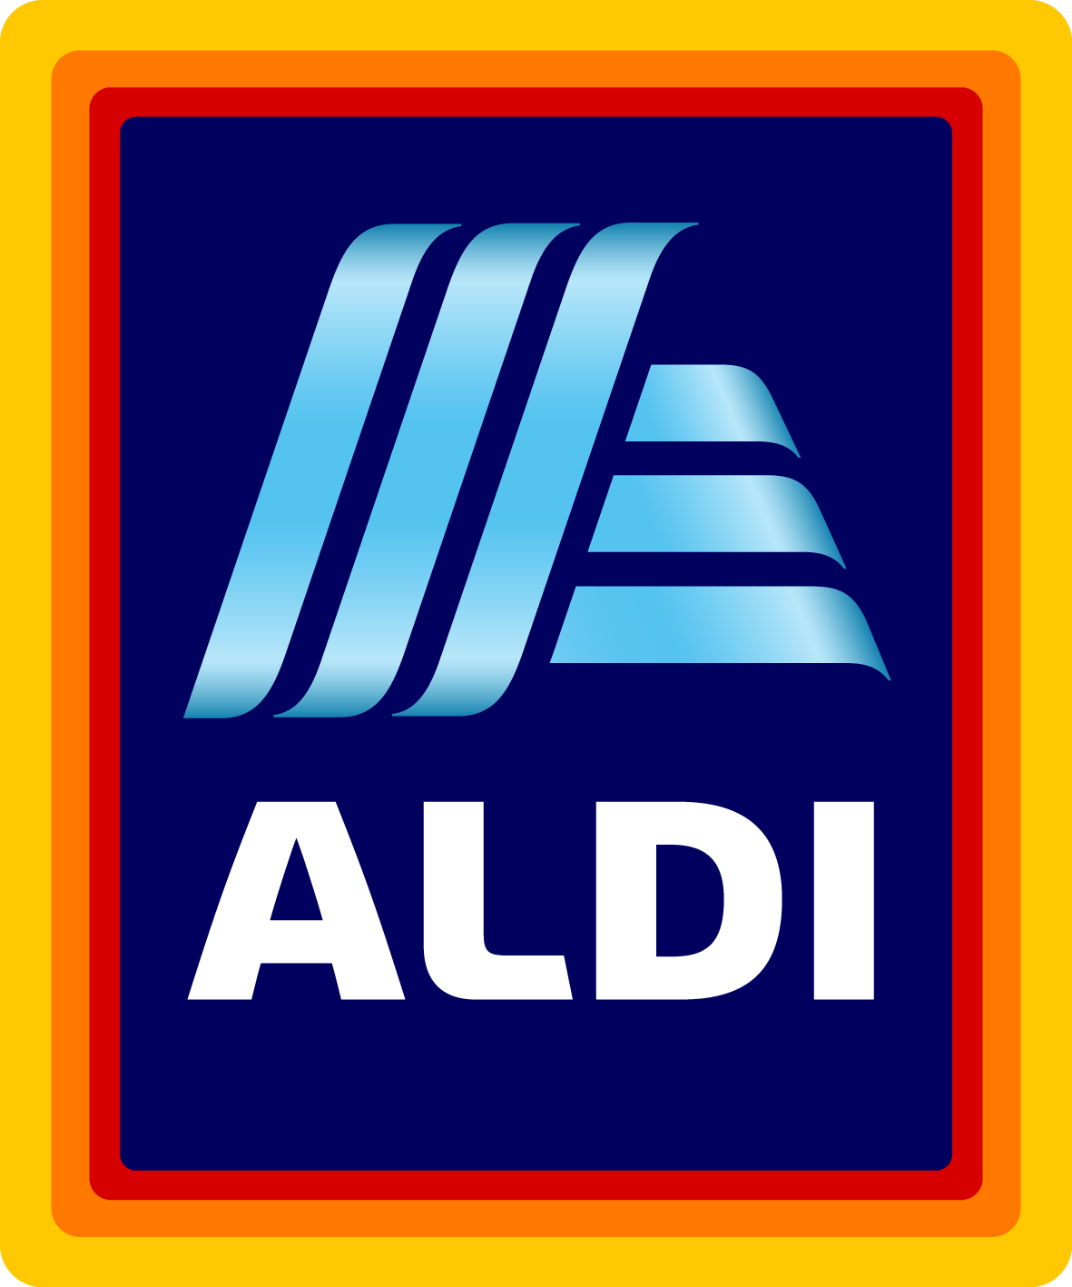

SUBMISSIONS WILL NOT BE CONSIDERED UNLESS COMPLETED IN FULL.

Date:
Company Name:
DUNS Number:
Company Headquarters Address:
City, State, ZIP, Country:
Company Headquarters Phone:
Contact Name and Title:
Contact Phone:
Contact Fax:
Contact Email:
Company Website:
Have you reviewed our Supplier Video? Yes No (https://corporate.aldi.us/en/suppliers/supplier-video/)
Have you reviewed ALDI FAQs? Yes No (https://corporate.aldi.us/en/suppliers/faqs/)
Can you uphold the ALDI Social Standards in Production at all levels of the supply chain? Yes No (https://corporate.aldi.us/fileadmin/fm-dam/Corporate_Responsibility2/CR_Policy/ALDI_SocialStandardsProduction_2017.pdf)

What year was your company started?
What are your annual sales?
Does your company have a U.S. or Canadian Sales Office? Yes No
Are you a broker? Yes No Are you a distributor? Yes No
Has your company ever supplied product to ALDI? Yes No
If so, please list the items supplied:
What U.S. retailers are you currently supplying?
Has your company shipped product to the United States? Yes No
Are you able to quote Duties Delivered Paid (DDP) at a U.S. port? Yes No
Production Facility Locations (Street Address, City, State and Country):

Where are your pick-up/shipping locations? (City, State and Country):

Have you visited our stores? Yes No
Does your company supply apparel or textiles? Yes No

What goods, supplies, equipment, or fixtures are you interested in supplying Aldi?

Please provide details for your top-selling item.
Product Name:
Detailed Description:

Product Features & Specifications:

Does your product include a warranty: Yes No
If yes, please provide specific warranty coverages:

In order to supply ALDI, your company must carry general and umbrella liability policies. Coverage requirements are based on product category and range from $2M each occurrence/ $3M aggregate to $10M each occurrence/$11M aggregate.
Can you provide proof of insurance? Yes No
If you do not currently have insurance, are you able to obtain the required coverage? Yes No
If you do not currently carry adequate coverage, are you willing to increase your policy terms to meet ALDI requirements? Yes No
Product carries the following certifications / meets the following standards (if applicable):
☐ UL Certification
☐ FDA (Indirect Food Contact)
☐ NSF Certification
☐ BIFMA Certification
☐ ASTM F2372-15
☐ ENERGY STAR®

Please return your completed document via email to suppliersourcing@aldi.us

Please refrain from sending samples unless requested.
*ALDI is not liable for any costs incurred by a supplier in attempt to meet ALDI requirements. An Applicant will not become an ALDI supplier until ALDI and the Applicant enter into a formal written agreement. Fees associated with packaging design and product testing are the responsibility of the supplier.

