New Supplier Application
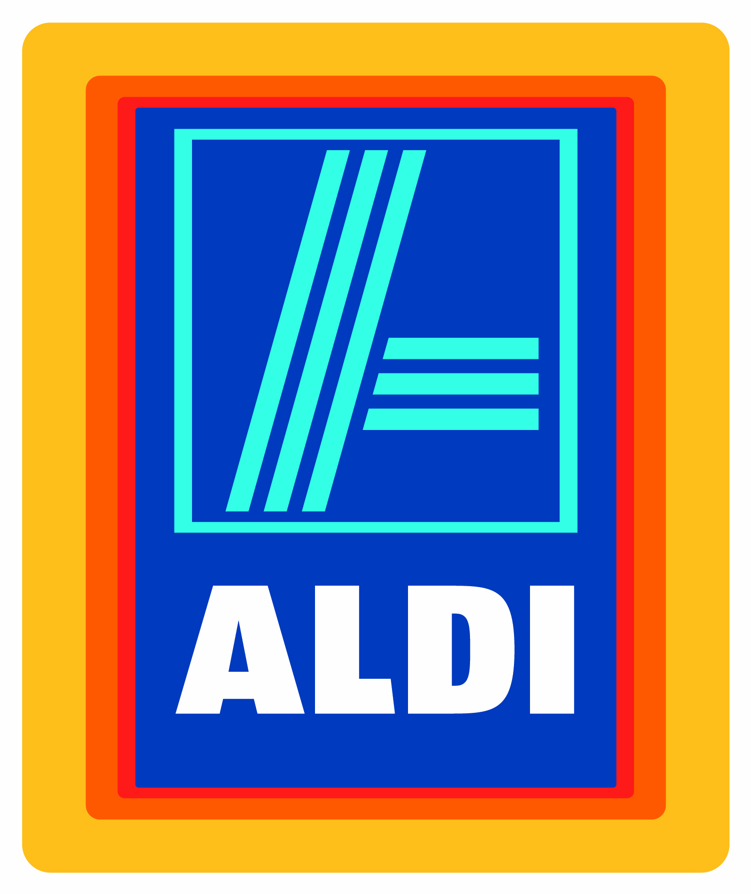

SUBMISSIONS WILL NOT BE CONSIDERED UNLESS COMPLETED IN FULL.
Date:
Company Name:
DUNS Number:
Company Headquarters Address:
City, State, ZIP, Country:
Company Headquarters Phone:
Contact Name and Title:
Contact Phone:
Contact Fax:
Contact Email:
Company Website: www.
Have you reviewed our Supplier Video? Yes No (https://corporate.aldi.us/en/suppliers/supplier-video/)
Have you reviewed ALDI FAQs? Yes No (https://corporate.aldi.us/en/suppliers/faqs/)
What year was your company started?
What are your annual sales?
Does your company have a U.S. or Canadian Sales Office? Yes No
Are you a broker? Yes No Are you a distributor? Yes No
Are your products co-packed? Yes No
Is your company able to produce items in Private Label? Yes No
Are you able to provide a mixed case of product (ie 2 or more variants per case): Yes No
Has your company ever supplied product to ALDI? Yes No
If so, please list the items supplied:
What US retailers are you currently supplying?

For whom do you currently produce private label products?

Has your company shipped product to the United States? Yes No
Are you able to quote Duties Delivered Paid (DDP) at a U.S. port? Yes No
Production Facility Locations (Street Address, City, State and Country):

Where are your pick-up/shipping locations (City, State and Country):

Are you familiar with our every day product line? Yes No
If not, please visit a store location.
What products within our everyday product line are you able to produce for ALDI?

ALDI Special Buys are two week in & out promotions that allow us to provide variety to our customers.
What special buy recommendations is your company able to produce for ALDI?

In order to supply ALDI, your production and warehouse facilities must receive an annual GFSI benchmarked audit or GMP audit from an approved third party (i.e. ASI, AIB, Silliker, NSF, Randolph Associates, SGS, Steritech, UL-STR, Guelph).
Can you provide documentation that an audit has been conducted for your facilities within the last 12 months? Yes No
If you do not currently have an audit on file, are you able to schedule an audit? Yes No
By 2015 ALDI will require all private label food production facilities to be GFSI Certified. Can you meet this requirement? Yes No

In order to supply ALDI, your company must carry general and umbrella liability policies. Coverage requirements are based on product category and range from $2M each occurrence/ $3M aggregate to $10M each occurrence/$11M aggregate.
Can you provide proof of insurance? Yes No
If you do not currently have insurance, are you able to obtain the required coverage? Yes No
If you do not currently carry adequate coverage, are you willing to increase your policy terms to meet ALDI requirements? Yes No
Please provide details for your top-selling item. For additional items, please complete Supplemental Product Submission Form/s available online at https://corporate.aldi.us/en/suppliers/become-a-supplier/
Product Name:
Detailed Description (ie. weight, pack size, material, color, etc):

Product Type: Dry Refrigerated Frozen General Merchandise
Can you produce a National Brand Equivalent? Yes No
Product Features / Claims (ie no artificial colors, BPA-free, no MSG, Made in USA, etc):

Minimum shelf life (in days) at delivery to ALDI warehouse:
Does your product include a warranty: Yes No
If yes, please provide details (US hotline):

Please provide Market Information for Same/Similar Product below:

- Based on overall sales for items you manufacture, where does this item rank?

- Please list the items whose sales rank higher than the proposed item.

- Please provide competitive market data to support the proposed item.

Current Retail for same/similar item: $ Oz. size:
Retailer Name:
Do you supply this item to the retailer above? Yes No

Current Retail for same/similar item: $ Oz. size:
Retailer Name:
Do you supply this item to the retailer above? Yes No

Current Retail for same/similar item: $ Oz. size:
Retailer Name:
Do you supply this item to the retailer above? Yes No

Please return your completed document via email to supplierinfo@aldi.us or via fax to 630.879.8114 or via mail to New Supplier Team, ALDI Corporate Buying, 1200 N. Kirk Rd., Batavia, IL 60510-1477.
Please refrain from sending samples unless requested.
*ALDI is not liable for any costs incurred by a supplier in attempt to meet ALDI requirements. An Applicant will not become an ALDI supplier until ALDI and the Applicant enter into a formal written agreement. Fees associated with packaging design and product testing are the responsibility of the supplier.

